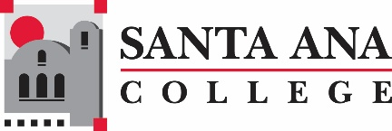

Distance Education Advisory Group Meeting

September 5, 2018

8:00am – 9:30am

SAC, A-101

**Distance Education Mission Statement:**

Our mission in Distance Education at Santa Ana College is to provide our students and faculty with the highest quality distance education program.  We accomplish this mission by assuring that our student coursework provides the depth and breadth of a quality post-secondary degree education while insuring the use of leading edge technology and excellence in teaching.

Agenda

# Welcome and Introductions. Meet Dr. Lamb

1. Accessibility Training & Video Creation Course Professional Development
2. Online Teaching Certificate
3. FARSCCD Proposal for DE
4. CVC – OEI Update
   1. Development Project – Faculty Participation
   2. Advisement Plan to Link to WebAdvisor  
      <https://sac.edu/AcademicAffairs/DistanceEd/Pages/Degree-Advisement-Plans.aspx>

Next Meeting, October 10th, 2018

***Santa Ana College Mission Statement:****Santa Ana College inspires, transforms, and empowers a diverse community of learners*.